**DAILY ONLINE ACTIVITIES SUMMARY**

|  |  |  |  |  |  |  |  |  |
| --- | --- | --- | --- | --- | --- | --- | --- | --- |
| **Date:** | **08/06/2020** | | | | | **Name:** | **Archana J C** | |
| **Sem & Sec** | **4th**  **‘A’** | | | | | **USN:** | **4AL18CS011** | |
| **Online Test Summary** | | | | | | | | |
| **Subject** | | **Data Communications** | | | | | | |
| **Max. Marks** | | **30** | | **Score** | | | **22** | |
| **Certification Course Summary** | | | | | | | | |
| **Course** | **Python and Django full stack web developer bootcamp** | | | | | | | |
| **Certificate Provider** | | | **Udemy** | | **Duration** | | | **2hours** |
| **Coding Challenges** | | | | | | | | |
| 1. **C Program to Generate All the Set Partitions of n Numbers Beginning from 1 and so on** 2. **Write a Java Program to check whether the given matrix is magic square or not** | | | | | | | | |
| **Status: Completed** | | | | | | | | |
| **Uploaded the report in Github** | | | | | **Yes** | | | |
| **If yes Repository name** | | | | | **https://github.com/alvas-education-foundation/archana_j_c** | | | |
| **Uploaded the report in slack** | | | | | **Yes** | | | |

Online Test Details: (Attach the snapshot and briefly write the report for the same)

The online test was from module 2, which was about Conformal transformation, Bilinear transformation, complex integration, Cauchy’s theorem, consequences of Cauchy’s theorem, Cauchy’s integral etc... There were 30 questions and the duration was 45 minutes. The questions were optimal. The score that I got in the test is 22/30.

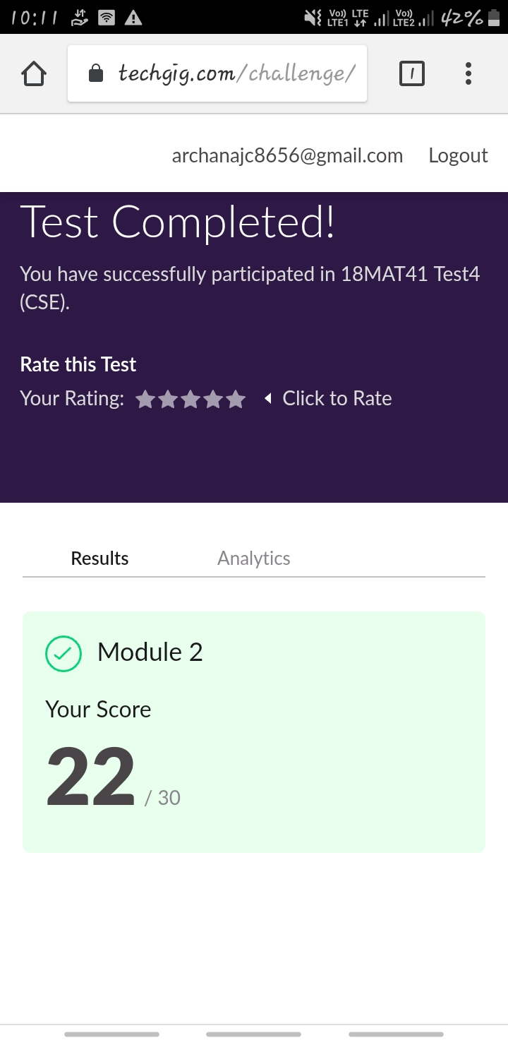

Certification Course Details: (Attach the snapshot and briefly write the report for the same)

COURSE NAME : **Python and Django full stack web developer bootcamp**

CERTIFICATION PROVIDERS : Udemy

The course is all about the web development. I was learnt about html and css, and how to code using html and I’m know in javascript advance.



Coding Challenges Details: (Attach the snapshot and briefly write the report for the same)

Today I’m done with some java and c programs. The solution are already uploaded in github repository

**Program1 : C Program to Generate All the Set Partitions of n Numbers Beginning from 1 and so on.**

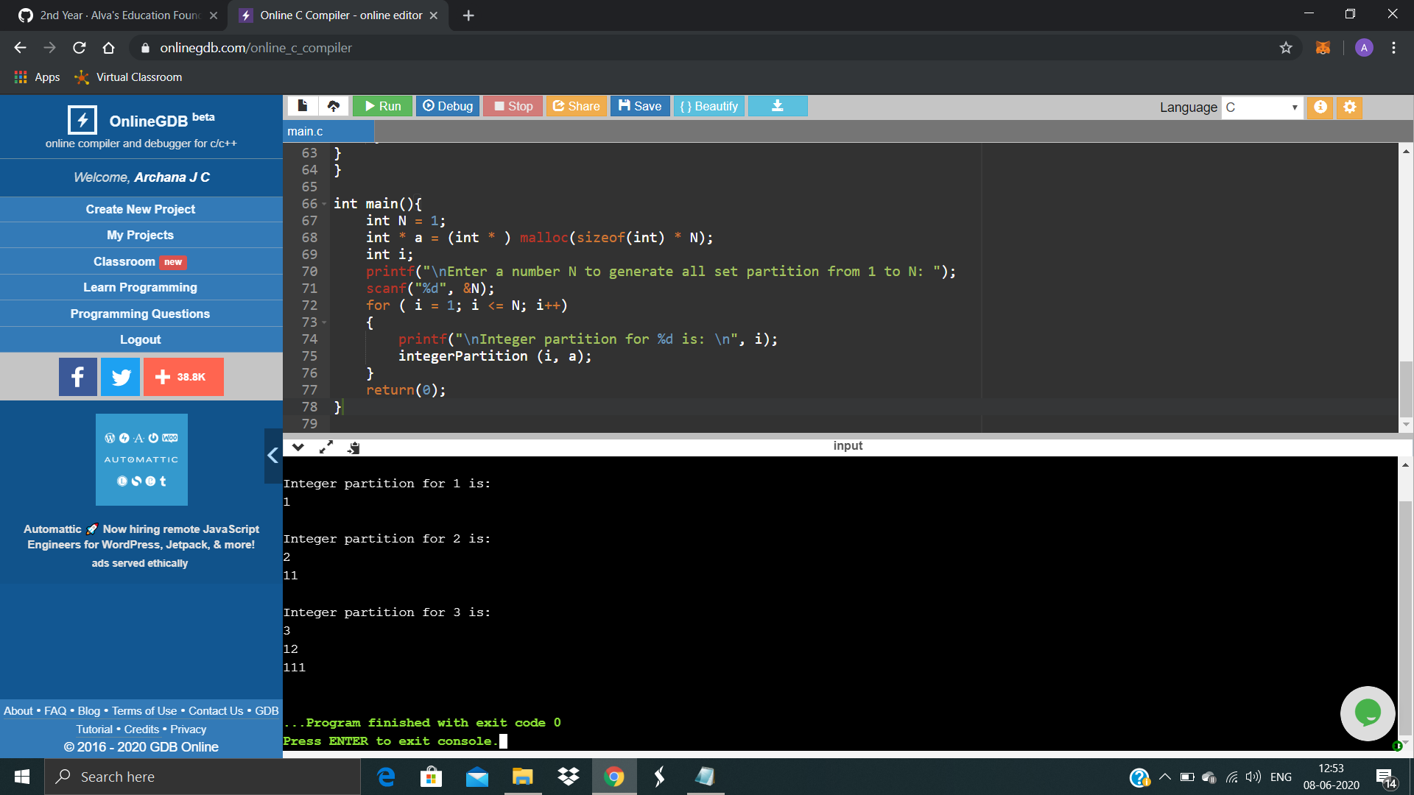

**Program2 : Write a Java Program to check whether the given matrix is magic square or not.**

